Resource | English Literature Revision Support |  |  |  | English Language Revision Support
Reading | - Macbeth  - Macbeth CGP text guide* | - A Christmas Carol  - A Christmas Carol CGP text guide* | - An Inspector Calls  - An Inspector Calls CGP text guide* | - Power & Conflict AQA Anthology  - Power & Conflict CGP text guide* | Challenging 21st century fiction eg Top Ten lists in The Guardian | High quality journalism eg  The Guardian, The Independent, i, The Times, The Telegraph |  | Collins Snap Revision*
Places to visit  (All free!) | Speke Hall,  The Walk,  Speke,  Liverpool  L24 1XD | St George’s Hall Heritage Centre  St George’s Place  Liverpool  L1 1JJ | Merseyside Maritime Museum  Albert Dock  Liverpool Waterfront  Liverpool  L3 4AQ | Museum of Liverpool  Pier Head  Liverpool Waterfront  Liverpool  L3 1DG | Walker Art Gallery  William Brown Street  Liverpool  L3 8EL  England |  | Any areas of outstanding natural beauty eg parks, woodland, beaches, mountain ranges, national parks etc
 |  |  |  |  | These places will provide inspiration for creative writing to support Language Paper 1.
Things to Watch | - Macbeth (1979) starring Ian McKellan as Macbeth  - Macbeth (2010) starring Patrick Stewart as Macbeth  - Macbeth (2015) starring Michael Fassbender as Macbeth  - Timeline- The Real Macbeth | - Scrooge (1951), starring Alastair Sim as Scrooge  - A Christmas Carol (2009), starring Jim Carrey as Ebenezer Scrooge and the three ghosts.  - A Christmas Carol (1999), starring Patrick Stewart as Ebenezer Scrooge.  - The Children Who Built Victorian Britain (BBC)  - Victoria (The ITV Hub) | - An Inspector Calls (1954) staring Alistair Sim as Inspector Goole  - An Inspector Calls (1982) available on youtube  - An Inspector Calls (2015) BBC  - Who do you think you are? (BBC iplayer) | - Andrew Marr’s- The Making of Modern Britain (BBC iplayer/youtube) | - Channel 4 news: weeknights from 7pm  - Panorama (BBC iplayer)  - Newsnight (BBC iplayer)  - Victoria Derbyshire (BBC iplayer)  - Question Time (BBC iplayer)  - The Andrew Marr Show (BBC iplayer)
 |  |  |  |  | These television shows will provide examples of high quality journalism and give different perspectives on current social issues to support Language Paper 2.
Websites | - http://www.nationalarchives.gov.uk/victorians/  - http://www.history.co.uk/  - https://www.shmoop.com/video/search  - www.sparknotes.com  - https://www.rsc.org.uk/shakespeare-learning-zone/macbeth |  |  | - https://www.bbc.co.uk/education/levels/z98jmp3 (Bitesize)  - https://www.youtube.com/user/mrbruff/playlists (Mr Bruff)  - www.bl.uk (British Library)  - https://www.youtube.com/channel/UC4KN50fal7f45fx2DqG7ttg (BBC teach)
Theatre | The Tempest  The Palm House, Sefton Park  Sun 11th August  Tickets from £9.90 | A Christmas Carol  St George’s Hall Concert Room  Wed 18th December 2019  Tickets from £20.00 | An Inspector Calls  The Lowry, Salford  Tues 14th –Sat 18th January 2020  Tickets from £8.75 | Roger McGough  Joinedupwriting  The Playhouse  Thurs 7th Nov 2019  Tickets from £10 | Mary Shelley’s Frankenstein  The Playhouse  Mon 11th - Sat 16th Nov 2019  Tickets from £10
Get creative | 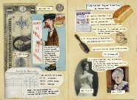  Scrap books | 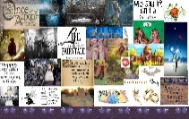  Mood boards | Pinterest | 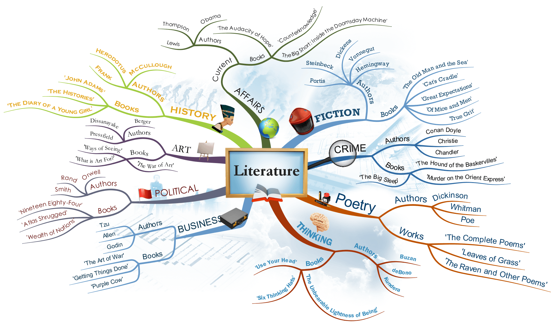  Mind-maps | 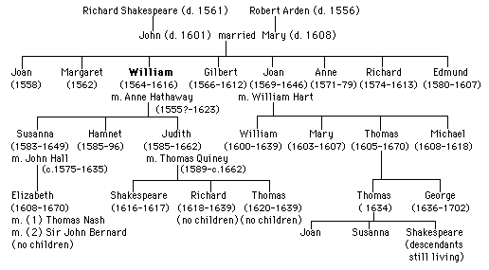  Family trees | 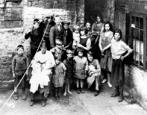  Photographs and drawings

