Dear Parent/Carer,
Important information about school shoes
When purchasing your child’s school shoes ready for the new academic year, can you please be mindful of the following school rule:

School shoes must be plain black, business style with leather upper. Large bows, coloured, silver or gold accessories are not permitted.

Some retailers call their training shoes, shoes so please always consider before purchasing ‘if it looks like a trainer it will not be permitted’.

To support you, please see below a selection of images that are acceptable and conversely ones that are not.

Acceptable: Not Acceptable:
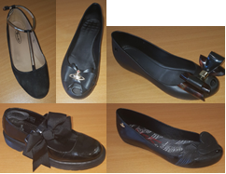

We obviously want every child to start a new academic year positively so please ensure your child has the correct footwear.
Thank you for your continued support.

Mrs A. Cundle
Assistant Headteacher

